Software Requirement Specification
For
Hotel Management System
Version: 1.0

Team Members: | - Naba Jafri  - Fatima Jamal.  - Amman Soomro

Table of Contents
1. Introduction 1
1.1 Purpose 1
1.2 Document Conventions 1
1.3 Abbreviations 1
1.4 Scope 2
1.5 References 2
2. Overall Description 3
2.1 Product Perspective 3
2.2 Product Functions 3
2.3 User Classes and Characteristics 4
2.4 Design and Implementation Constraints 5
2.5 Assumptions and Dependencies 5
3. External Interface Requirements 5
3.1 User Interfaces 5
3.2 Hardware Interfaces 6
3.3 Software Interfaces 6
3.4 Communications Interfaces 6
4. System Features 6
4.1 Login 6
4.1.1 Description and Priority 6
4.1.2 Functional Requirements 7
4.2 Customer Access 7
4.2.1 Description and Priority 7
4.2.2 Functional Requirements 7
4.3 Receptionist Access 7
4.3.1 Description and Priority 7
4.3.2 Functional Requirements 7
4.4 Manager Access 8
4.4.1 Description and Priority 8
4.4.2 Functional Requirements 8
5. Other Nonfunctional Requirements 8
5.1 Performance Requirements 8
5.2 Security Requirements 8
5.3 Capacity Requirements 9
5.4 Software Quality Attributes 9
6. Other Requirements 9
6.1.1 USECASE: 10
6.1.2 Engagement Matrix 10
6.1.3 Engagement Matrix 11
6.1.4 Role Traceability Matrix 11

Revision History
Name | Date | Reason for Changes | Version
Amman Soomro  Naba Jafri  Fatima Jamal | 10-12-2020 | I am Everything (Naba Jafri) | 1.0
Amman Soomro | 14-12-2020 | Added Use case | 1.0
Fatima Jamal | 15-12-2020 | Added Architecture Design | 1.0

Introduction
The Hotel Management System is a tool for booking the rooms of Hotel through online by the Customer. It provides the proper management tools and easy access to the customer information.

Purpose
The purpose of this document is to describe the requirements of Hotel Management System. This document will allow the reader to understand the main use cases, functional and non-functional requirements of the project that has to be developed. Requirements of customer, manager and receptionist are thoroughly analyzed.
This SRS for HMS can also be used for future as basis for detailed understanding on how project was started.

Document Conventions
Font: Times New Roman
Font Size: 14-32

Abbreviations
HMS | Hotel Management System
SRS | Software Requirement System
DBMS | Database Management System
FR | Functional Requirement
NFR | Non-Functional Requirement
GUI | Graphical User Interface
MySQL | It is an open-source relational database management system. Its name is a combination of "My", the name of co-founder Michael Wideness’s daughter, and "SQL", the abbreviation for Structured Query Language.
PKR | Pakistani Rupee.
HTTP | Hypertext Transfer Protocol
HTTPS | Hypertext Transfer Protocol Secure

Scope
Hotel management is not only confined to hotel but had gone deep into airlines, clubs etc. Our HMS project is intended for the reservations of room that can be made through online. It can systematize various operations of the Hotel.
Our Hotel Management System will have three end users: Customer, Receptionist, and Hotel Manager.

Customer can book a room.
Managers have the access to add information concerning room, driver, and employee. Moreover, Manager also have the access to details regarding him, customer, and employee.
Receptionists have the access to update room information and details regarding customer etc.

The goal of this automated HMS software is to simplify everyday process of hotel. This automation efficiently takes care of customer services. It provides quick retrieval of information, ease of use, and quick recovery of errors. It also overcomes the drawbacks of large customer information physical files which were difficult to handle.

References
- https://app.creately.com/diagram/AqbISJqciuX/edit
- https://dipeshagrawal.files.wordpress.com/2018/07/srs-hotel-management-system-ok.pdf
- Software Engineering 9th Edition, Ian Sommerville.
- Requirements Engineering: A Good Practice Guide by Ian Sommerville and Peter Sawyer.

Overall Description

Product Perspective
The product is a new, self-contained product and the key perspective of this software is to provide an online platform to book rooms for hotel with secure payment option.
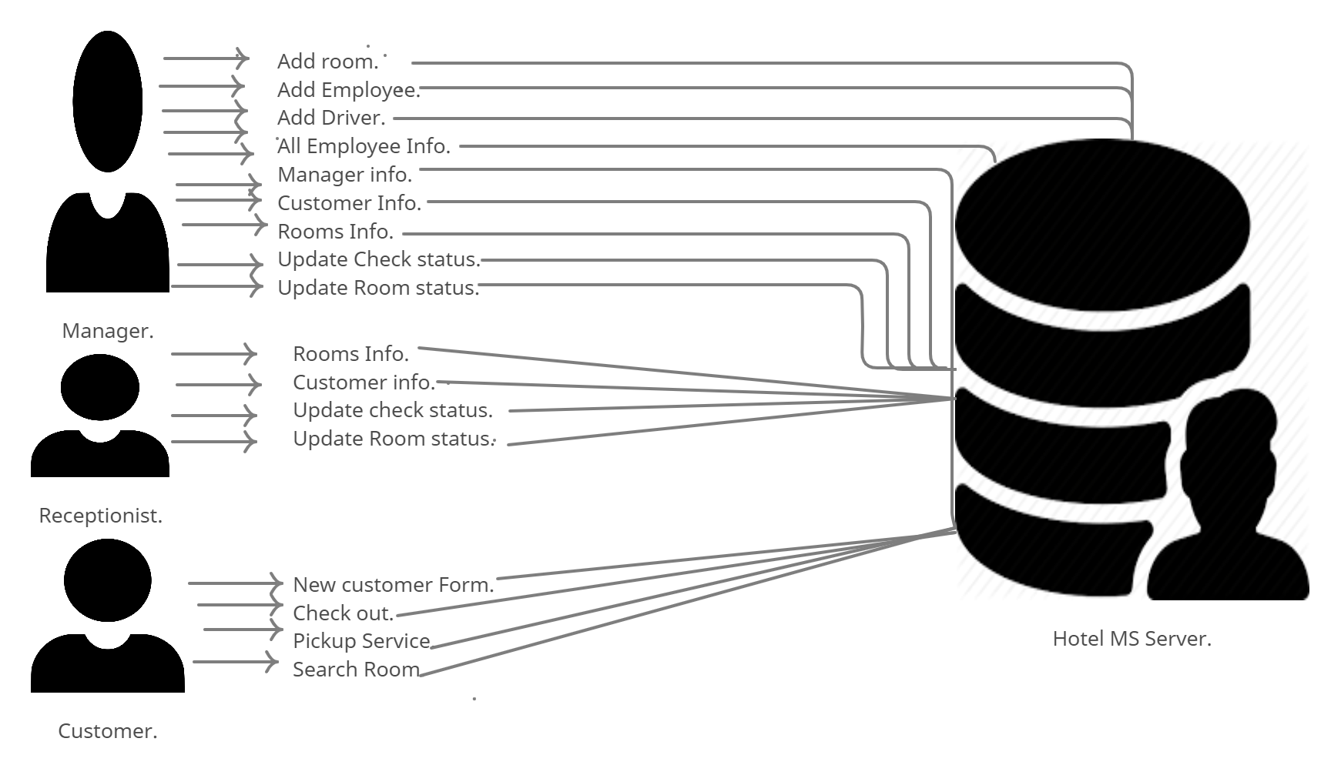
This is basically similar to going hotel and booking a room there. But with the use of computers for creating online dais it will be easy for people to book room at any time.

Product Functions
- Has fixed rate of rooms.

- Customer will be provided rooms on the basis of room availability.

- Enables the input of manager’s information.

- Enables the input of employee’s information.
- Confirmation of booking.

- Modification and updating of information on booking room and access details of room, customer, and manager by receptionist.

- When customer checks in or checks out their detail will be updated in database.

- Customer registration.

- Customer can search for room.

- User can logout at any time.

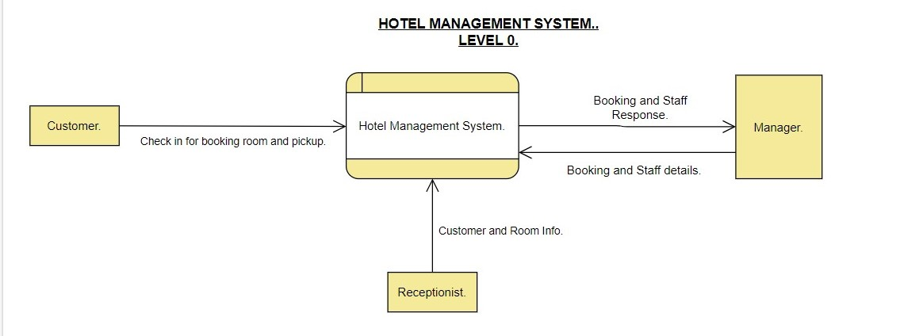
- Users can login by their username and password.

User Classes and Characteristics
There are 3 users:

- Customer

- Manager

- Receptionist

Customer: Customer is the main part of HMS system. Customer can book room online and they can select the type of room they want (double bed room / single bed room) based on its availability. They can check in and check out. Customer can also check the status of room and its price.

Manager: Manager have access to the whole system. He / She manages hotel staff and its resources. Manager can also add employee, add room (add single room / add double room), and add driver (in case we want to pick any customer from certain location).

Receptionist: The main attribute of receptionist is to provide customer service. He/ She have least access then the Manager. She can book room for customer according to the availability of rooms, confirm the booking, and manage the booking details. He/ she should have basic IT knowledge and should have experience of equal to or more than 3 years.

Design and Implementation Constraints
- Language requirements: Software must only be in English Language.

- It should be Java based.

- HMS will be amazingly simple and have only basic functionalities due to limited budget.

- Database is password protected.

- Each customer will have individual IDs to book hotel.

- Timing requirements: minimum response time should be around 2 seconds and maximum will be 5 seconds.

- Interface: Should have more colors that will give an elegant look.

- SQL server will be used.

Assumptions and Dependencies
- Language of GUI will be English based.

- User must have a valid id and password to login.

- Only Manager and Receptionist are allowed to update records.

- System developed will work perfectly under Windows OS and if there is any difficulty the SRS is flexible enough to change accordingly.

- No facility for guest and login and password is used for only user identification.

External Interface Requirements

User Interfaces
The user interface is suitable for any type of Operating system like Windows XP, Windows 7, Window 8, and Windows 10.

Hardware Interfaces
 | Server side | client side
Monitor | Resolution: 1024 x 768 | Resolution: 1024 x 768
Processor | Intel or AMD 2GHZ | Intel or AMD 1GHZ
RAM | 4GB | 512 MB
Disk Space | 10GB | 2GB

Software Interfaces

Database server: OS (Windows), MySQL
.
Development End: Java, OS (Windows).

Communications Interfaces
To connect all the systems of hotels there must be a network connected in between them. By this after every transaction the data will be updated in every computer. Moreover, the system shall be using HTTP/HTTPS for communication over the internet.

System Features

Login

Description and Priority
Priority: High
Description: This function helps the user to login the system if the entered user id and password are authentic.

Functional Requirements
- The system should verify user id and password with the information present in database.
(FR 01)

- After login home screen will be shown with three options: Receptionist, Customer, and Manager for user to select their category. (FR 02)

Customer Access

Description and Priority
Priority: High.

Description: This function helps the customer to book a room according to its availability, status, and price.

Functional Requirements
- The system should allow the customer to search for the availability of room. (FR 03)

- The system should enable customer to use pickup service. (FR 04)

- They system should enable customer fill customer form that includes all details related to customer for example: ID, Name, Number, Gender, Country, Room Number, Check in, Deposit etc. (FR 05)

- The system should record booking details into database. (FR 06)

- The system should allow customer to check out. (FR 07)

Receptionist Access

Description and Priority
Priority: High.

Description: This Function helps the user to fulfill all customer services.

Functional Requirements
- The system should allow the user to have access to room information which includes: Room Number, Availability, Clean Status, Price, and Bed Type. (FR 08)

- The system should allow Manager to have access to customer information. (FR 09)

- The system should enable user to update check-in status (ID, Room Number, Name, Checked-in, Amount Paid (PKR), Pending Amount (PKR) and room details (Guest ID, Room Number, Availability, Clean Status). (FR 10)

Manager Access

Description and Priority
Priority: High.

Description: This function allows the user to have whole access of the system.

Functional Requirements
- The system should enable manager full modification access to Customer, Employee, Booking and Room information. (FR 11)

Other Nonfunctional Requirements

Performance Requirements
- Information gets updated within database in 2 seconds when user register themselves. (NFR 1)

- Information gets displayed within 2 seconds. (NFR 2)

- Login can be done by user within 2-3 seconds. (NFR 3)

Security Requirements
- Detail of customer, manager, and receptionist should be fully secured. (NFR 4)

- Only Manager have more access than receptionist and customer. (NFR 5)

- Each user must have their own authentication id and password. (NFR 6)

- Every external communication among the data’s server and user must be encoded. (NFR 7)

- Any modification in database shall only be done by Manager. (NFR 8)

- . Payment Process should use HTTP over Secure protocol to secure the payment transactions. (NFR 9)

Capacity Requirements
- Not more than 5000 members to be registered. (NFR 10)

Software Quality Attributes
Correctness: HMS system fulfills all of the basic operations/functions that a hotel should have in order to satisfy end-user needs.

Portability: System should run in Microsoft Windows environment.

Maintainability: System should be maintainable enough.
Testability: The system should be testable so that it can be verified whether the system fulfils user needs or not.

Flexibility: The system should be flexible enough to cope up with new features and handle them efficiently.

Consistent: The system should have a consistent design throughout the interfaces.

Other Requirements
- The details of customer like: ID, Name, Number, Gender, Country, and Room Number, check in, Deposit will be saved in database.

- The details of room like: Room Number, Availability, Cleaning Status, Price, Bed Type will be saved in database.

- The details of driver like: Name, Age, Gender, Car Company, Car Brand, Available, Location will be saved in database.

- Information of all Employees like: Name, Age, Gender, Job, Salary, Phone Number, CNIC, and Email will be saved in database.

- The check-in and room status will be updated in database.
Appendix A: Glossary
Database: A database is an organized collection of data, generally stored and accessed electronically from a computer system.

Functional Requirements: A Functional Requirement (FR) is a description of the service that the software must offer.

Non-Functional Requirements: A non-functional requirement is a requirement that specifies criteria that can be used to judge the operation of a system, rather than specific behaviors. They are contrasted with functional requirements that define specific behavior or functions.
Appendix B: Analysis Models

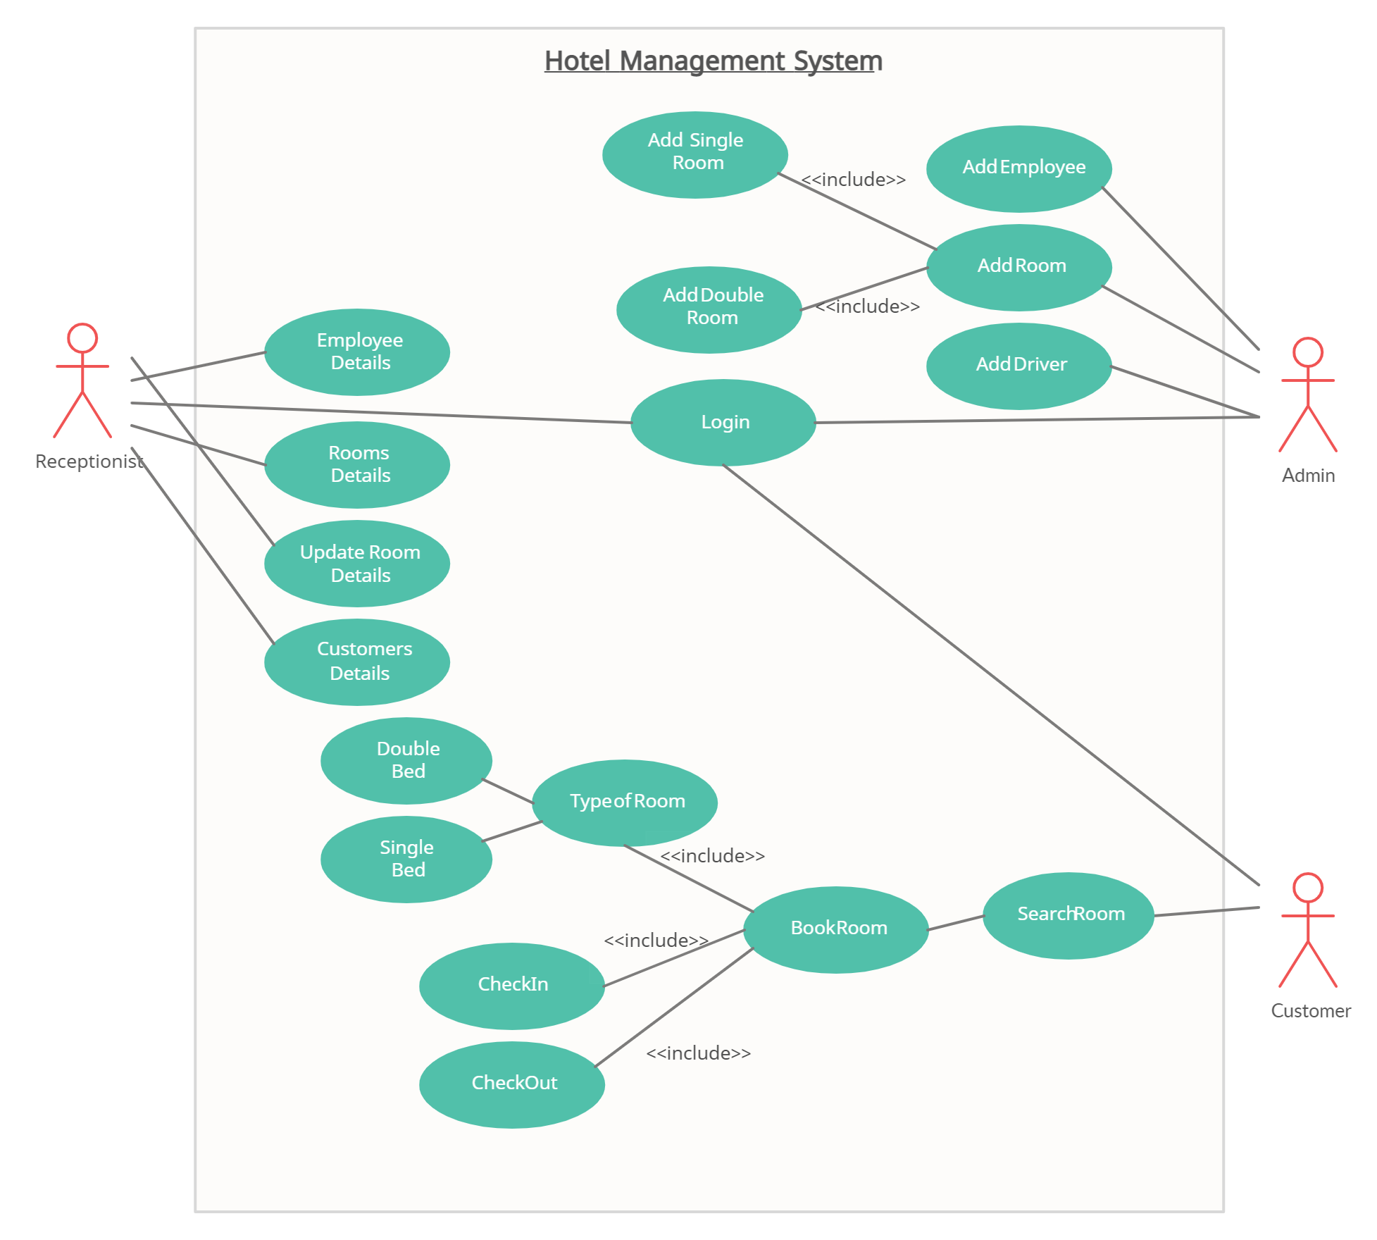
USECASE:

Engagement Matrix
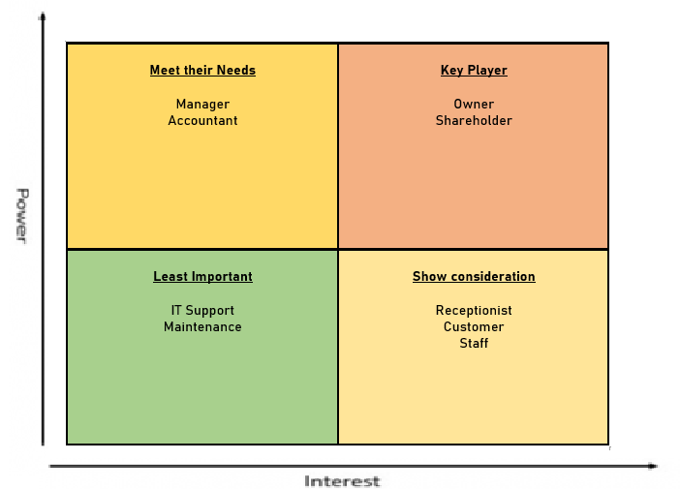

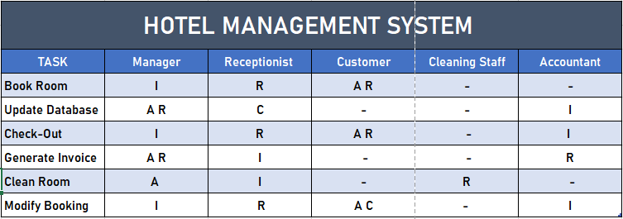
RACI Matrix

Role Traceability Matrix

